**User Guide: Jose Rizal Memorial State University Event Attendance Management System**

* **Introduction**

This user guide provides instructions for accessing and using the Jose Rizal Memorial State University Event Attendance Management System. Please note that the features and functionalities you see within the system will depend on your assigned user role (e.g., Student, Administrator, Event Organizer, SSG Officer).

1. **Accessing the System**
2. Open your preferred web browser (e.g., Google Chrome, Mozilla Firefox, Microsoft Edge).
3. In the address bar, type the web address for the system: `http://localhost:5173` (Note: This address might be different depending on the actual setup. Please use the correct address provided by the system administrators).
4. Press the **Enter** key. This will direct you to the login page, as shown below:

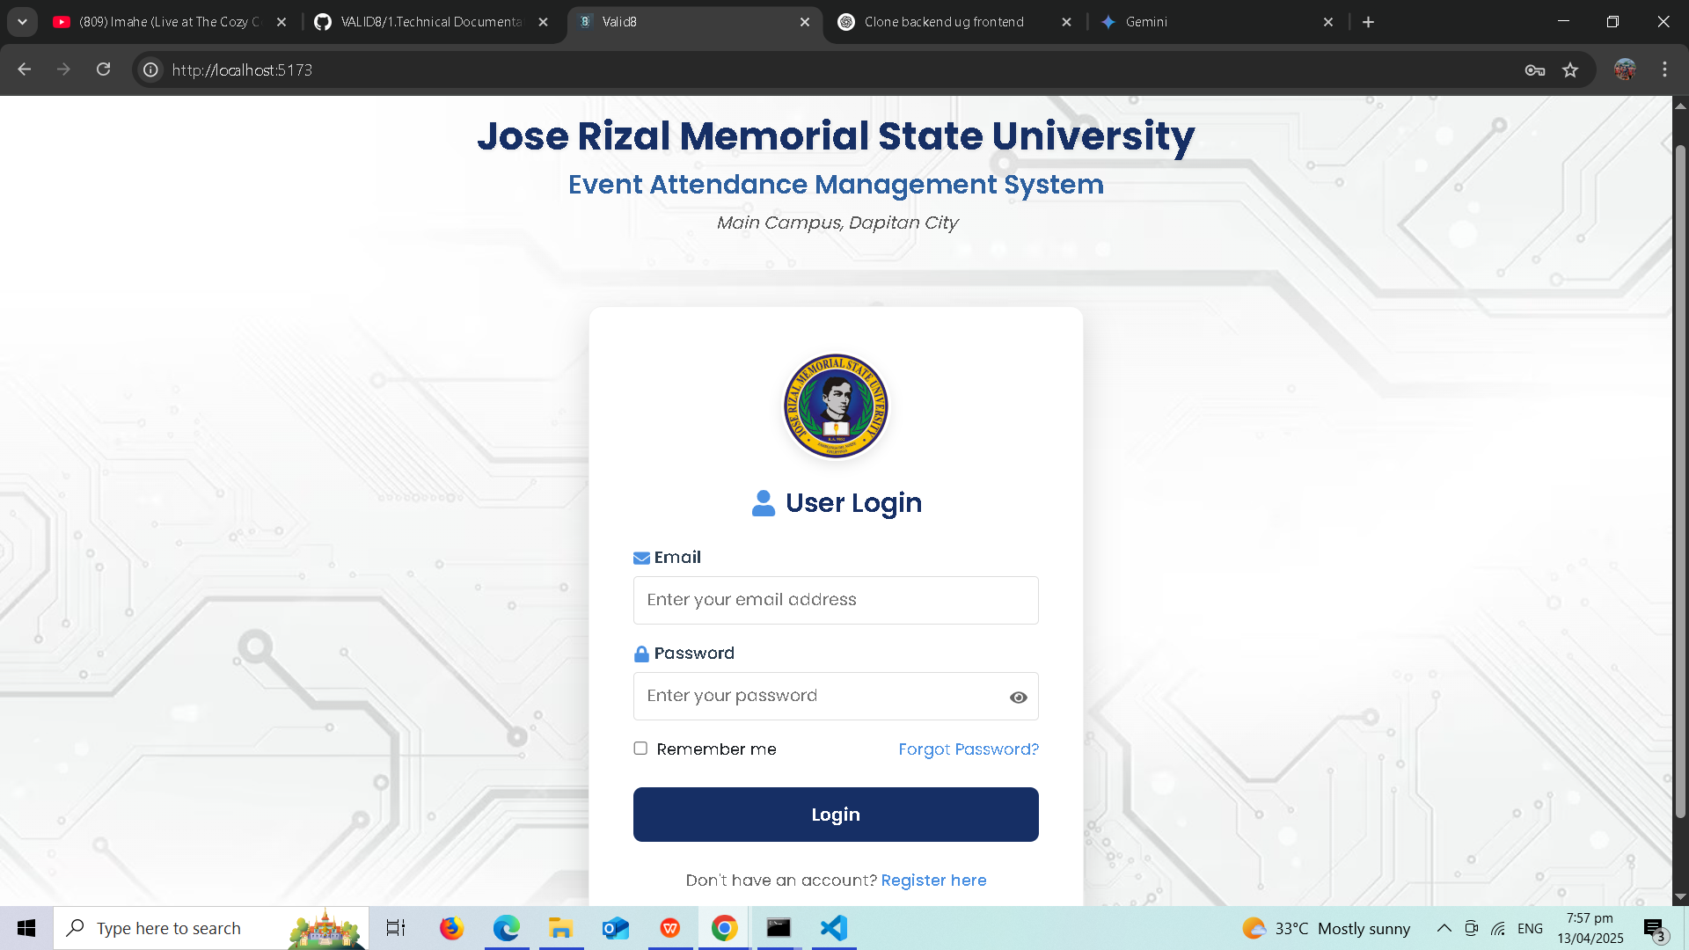

**2. Login or Registration**

This page allows existing users to log in and may also provide an option for new users to register (if enabled).

2.1. Login for Existing Users

**Email:** Enter your registered email address in the "Email" field.

**Password:** Enter your password in the "Password" field.

**(Optional) Remember me:** Check this box on personal devices.

**Forgot Password?:** Click this link if you have forgotten your password.

Click the **Login** button.

2.2. Registration for New Users (If Applicable)

* If the system allows self-registration, there may be a link such as "**Don't have an account? Register here**" below the login button.

* Clicking this link will take you to a registration form where you will need to provide your details (e.g., Name, Email, Student ID, etc.).

* Follow the on-screen instructions to complete the registration process.

**3. After Logging In**

Upon successful login, the system will recognize your user role based on your credentials and direct you to the appropriate section of the system. Please refer to the relevant part of this user guide based on your role:

* **If you logged in with an Administrator account, please proceed to the "Administrator User Guide" section below.**

* If you logged in with a Student account, please refer to the "Student User Guide" (which will be provided in a separate section of this document).

* (Sections for other roles like Event Organizer and SSG Officer would follow here if you want to include them in this comprehensive guide).

**3. Admin Dashboard Overview**

Upon successful login with your administrator credentials, you will be directed to the **Valid8 Admin Dashboard**, as shown below:

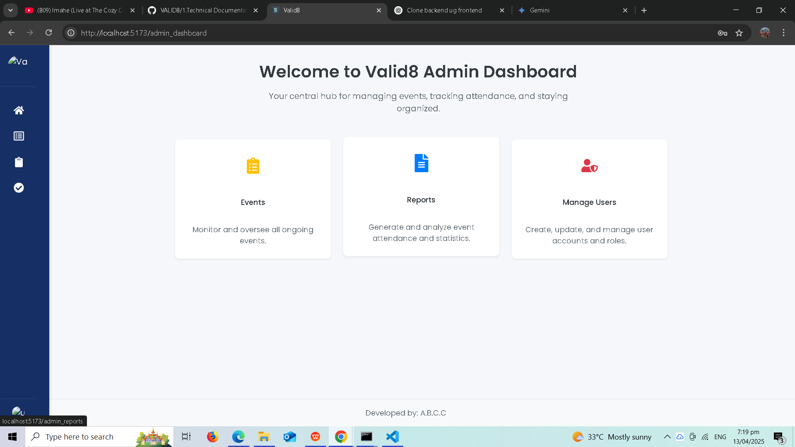

This dashboard serves as your central hub for managing the Event Attendance Management System. It provides a quick overview of key functionalities and allows you to navigate to different sections of the system. Typically, you will see various modules or panels offering access to different management areas. In this dashboard, you can see the following main sections:

* **Events:** Allows you to monitor and oversee all ongoing and upcoming events.

* **Reports:** Dedicated to generating and analyzing event attendance statistics.

* **Manage Users:** Provides tools for creating, updating, and managing user accounts and their roles. The sidebar on the left also offers quick navigation to these main sections and your profile.

**4.1. Adding a New User**

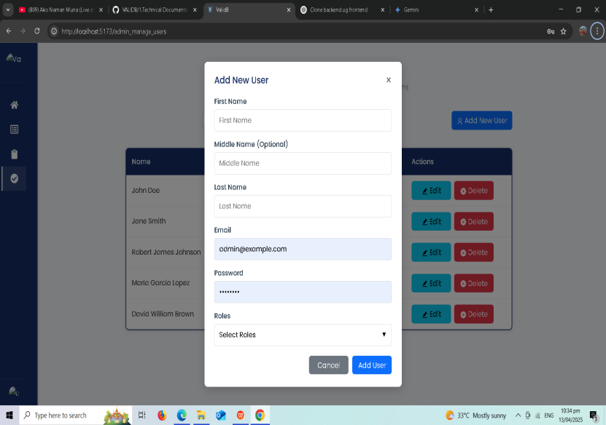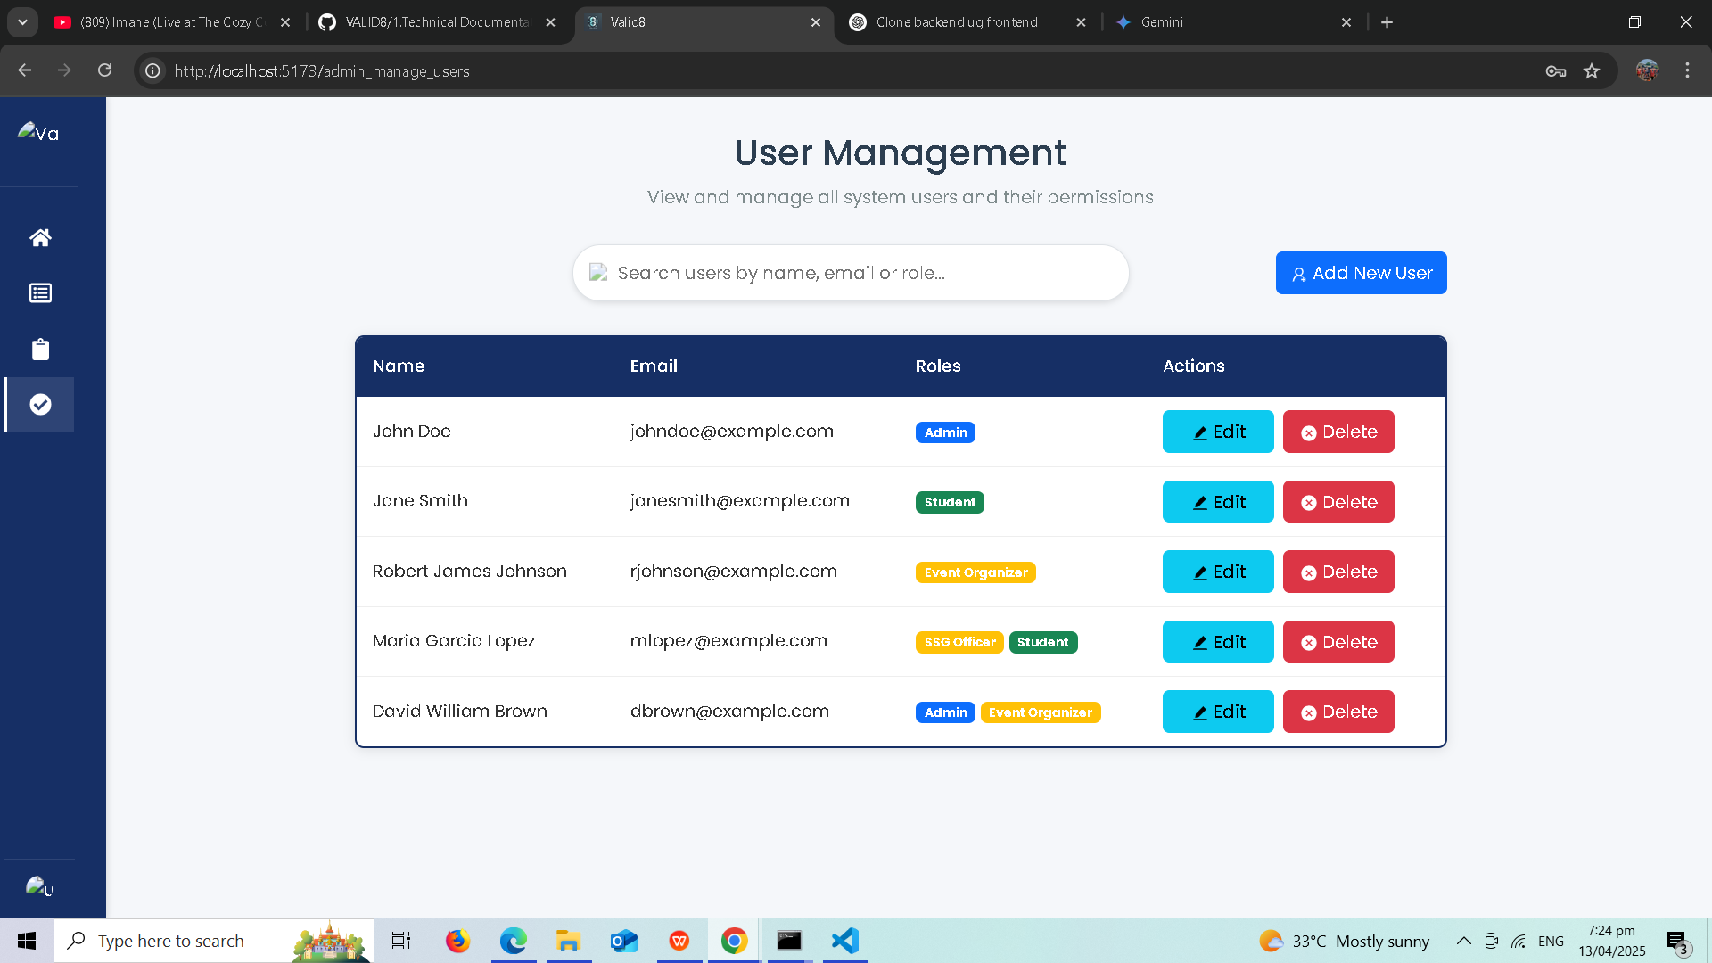

Clicking the "**+ Add New User**" button opens the "**Add New User**" modal. This modal contains the following fields to create a new user account:

* **First Name:** Enter the first name of the new user.

* **Middle Name (Optional):** Enter the middle name of the new user, if applicable.

* **Last Name:** Enter the last name of the new user.

* **Email:** Enter the unique email address for the new user's account (their login).

* **Password:** Enter a secure password for the new user.

* **Roles:** Select the appropriate role(s) for the new user (e.g., Student, Event Organizer, SSG Officer).

Click the **"Add User"** button to create the new account or **"Cancel"** to close the modal.

**4.2. Editing a User**

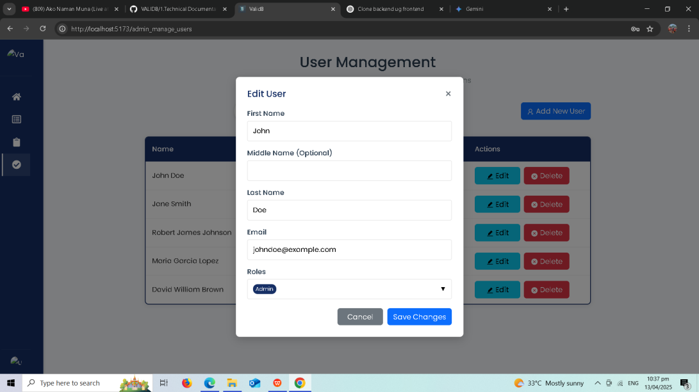

To modify an existing user's information:

1. On the **User Management** page, locate the user in the list.

2. Click the **"Edit"** button in the "Actions" column. This opens the **"Edit User"** modal:

3. Modify the necessary fields (First Name, Middle Name, Last Name, Email, Roles).

4. Click **"Save Changes"** to update the user's information or **"Cancel"** to close without saving.

**4.3. Deleting a User**

To remove a user account, click the **"Delete"** button in the "Actions" column next to the user. Confirm your decision when prompted. **Exercise caution when deleting users.**

**5. Managing Events**

Clicking on the **"Events"** option in the sidebar will navigate you to the **Events Management** page:

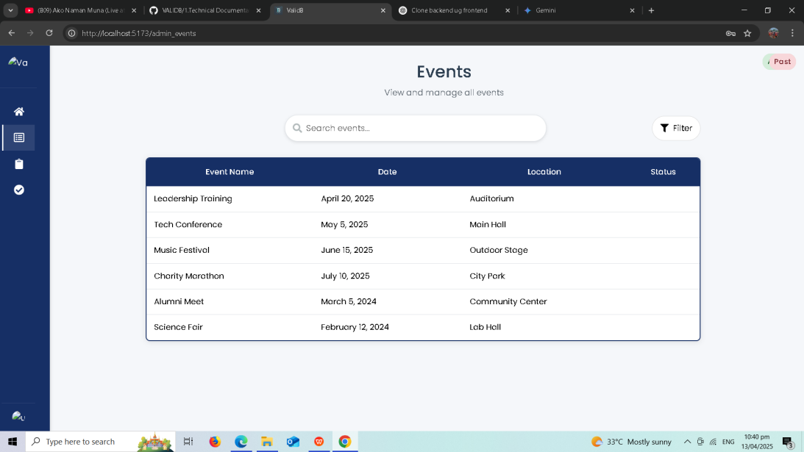

This page allows administrators to view, search, filter, and manage all events in the system.

**5.1. Viewing and Searching Events**

The page displays a list of events with details like Event Name, Date, Location, and Status. Use the "**Search events...**" bar to find specific events.

**5.2. Filtering Events**

Click the **"Filter"** button to narrow down the event list based on criteria like date range or status.

**6. Generating and Viewing Reports**

Clicking on the **"Reports"** option in the sidebar will navigate you to the **Event Attendance Reports** page:

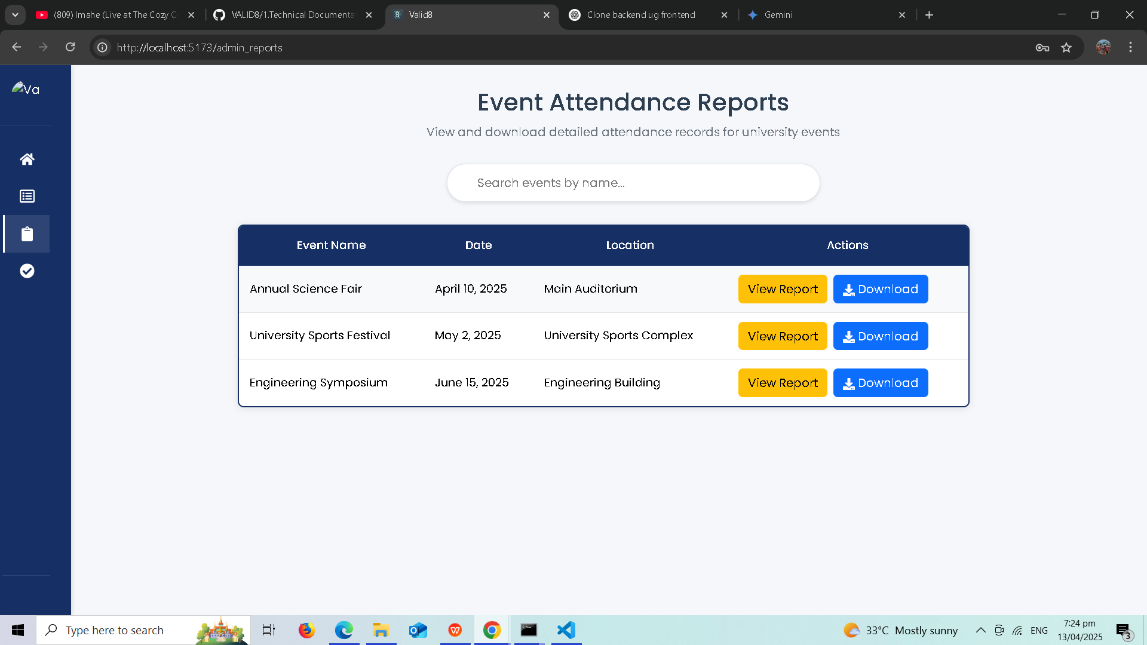

This page allows administrators to view and download attendance records for university events.

**6.1. Searching for Reports**

Use the "**Search events by name...**" bar to find reports for specific events.

**6.2. Viewing and Downloading Reports**

The table lists events with "View Report" and "Download" buttons in the "Actions" column. Click **"View Report"** to see the report on-screen or **"Download"** to save it to your computer (likely in CSV or PDF format).

## 7. Managing Your Profile

Clicking on the **"Profile"** option in the sidebar will navigate you to the **User Profile** page:

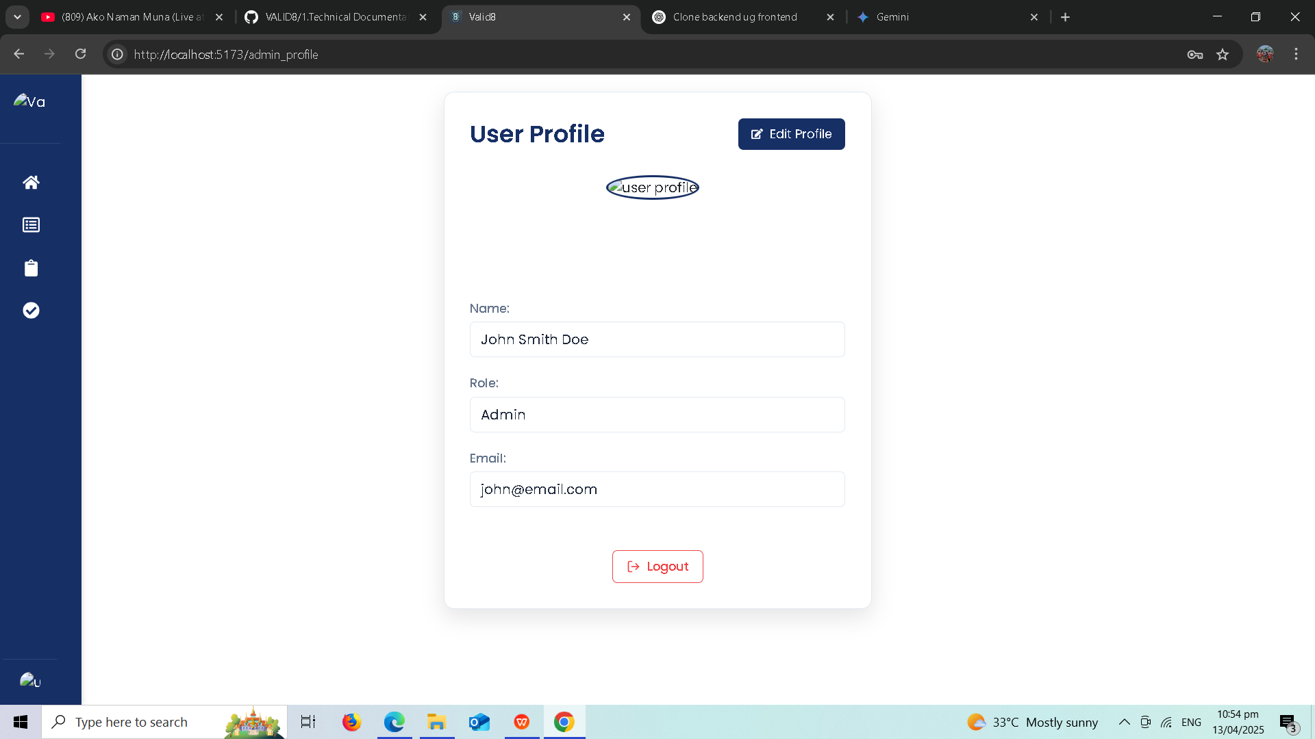

This page displays your account information (Name, Role, Email) and provides options to:

* **Edit Profile:** Click the "**Edit Profile**" button to modify your information or password.

* **Logout:** Click the "**Logout**" button to securely sign out of the system.

**7.1. Logging Out**

1. On the **User Profile** page, click the **"Logout"** button.

2. A **"Confirm Logout"** modal will appear:

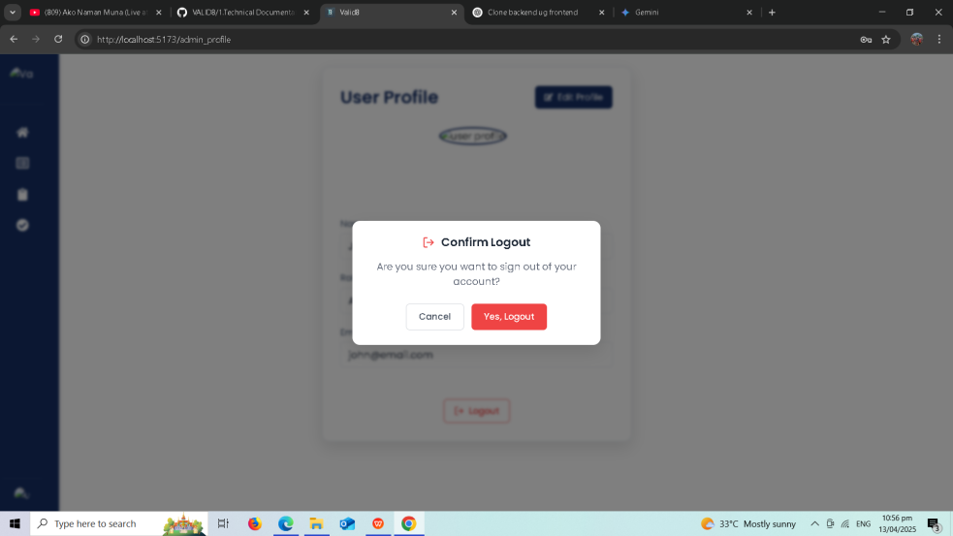

3. Click **"Yes, Logout"** to confirm and sign out, or **"Cancel"** to stay logged in.

## Conclusion

This Admin User Guide provides an overview of the key administrative functionalities within the Jose Rizal Memorial State University Event Attendance Management System. By utilizing these tools, administrators can effectively manage users, events, and attendance data. For further assistance or if you encounter any issues, please contact the system administrators or the IT support department at Jose Rizal Memorial State University.

1. **Student Dashboard Overview**

Upon successful login with your student account, you will be directed to the **Valid8 Student Dashboard**, as shown below:

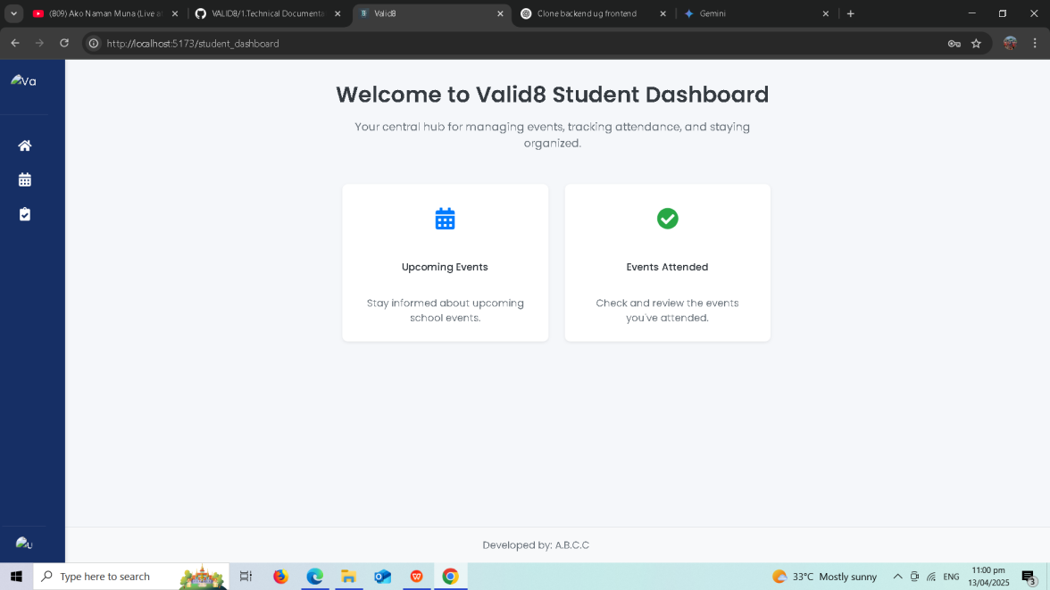

**3. Browsing Upcoming Events**

Clicking on the **"Upcoming Events"** panel on the dashboard or the **"Events"** icon in the sidebar will take you to the **Upcoming Events** page, as shown below:

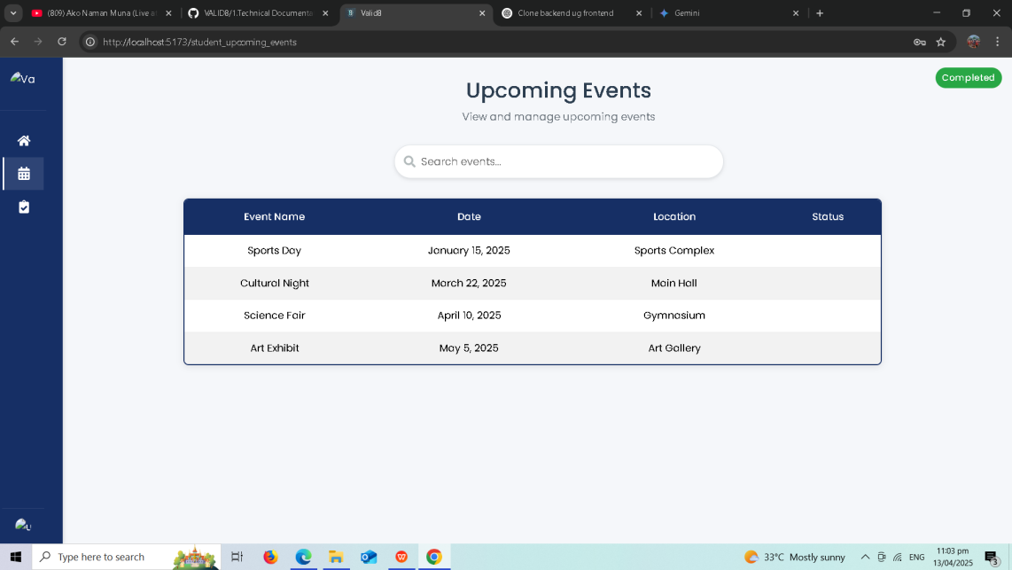

This page displays a list of events that are scheduled to occur in the future. It allows you to quickly see the important details of these events.

You can use the "**Search events...**" bar to find specific events and potentially filter them using the filter icon (if available).

Clicking on an event name might take you to more detailed information and registration options (if enabled).

1. **Viewing Your Attendance History**

Clicking on the **"Events Attended"** panel on the dashboard or the "Reports/Attendance" icon in the sidebar will take you to the **Events Attended** page, as shown below:

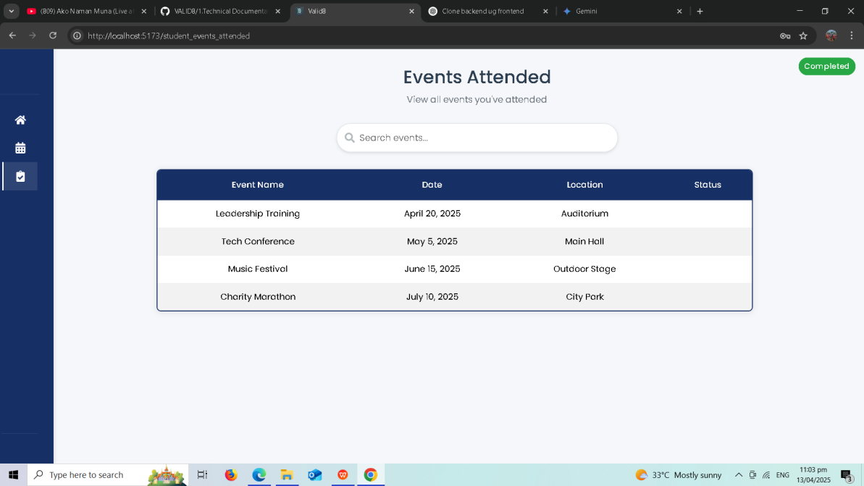

**5. Managing Your Profile**

Clicking on the **"Profile"** option in the sidebar will navigate you to your **User Profile** page, as shown below:

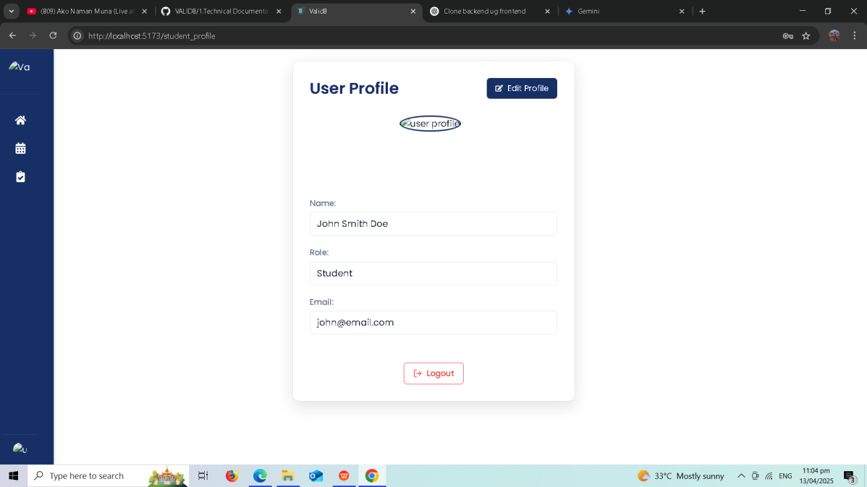

This page displays your personal account information (Name, Role: Student, Email). You can also **Edit Profile** and **Logout** from this page.

**5.1. Editing Your Profile**

Clicking the **"Edit Profile"** button will likely open the **Edit Profile** view, as shown below:

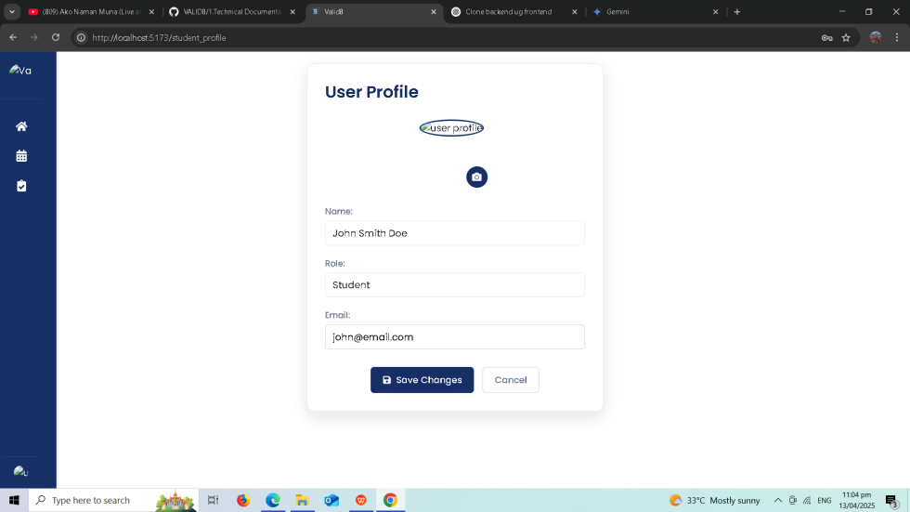

This view allows you to modify certain aspects of your profile, such as your profile picture (via the camera icon). You might also be able to change other personal details depending on the system's configuration. Click "**Save Changes**" to apply any modifications or "**Cancel**" to return to your profile.

**5.2. Logging Out**

The "**Logout**" button on the User Profile page allows you to securely sign out of the system when you are finished. You will likely be asked to confirm your action before being logged out.

**Conclusion for Student Users**

This user guide provides an overview of the key features available to you as a student within the Jose Rizal Memorial State University Event Attendance Management System. You can use the dashboard to stay informed about upcoming events and review your attendance history. The "Events" section allows you to browse and potentially register for events, and the "Profile" section lets you manage your account information and securely log out. If you have any questions or encounter issues, please contact the system administrators or the IT support department at Jose Rizal Memorial State University.

---

**Event Organizer User Guide**

**1. Event Organizer Dashboard Overview**

Upon successful login with your event organizer account, you will be directed to the **Valid8 Event Organizer Dashboard**, as shown below:

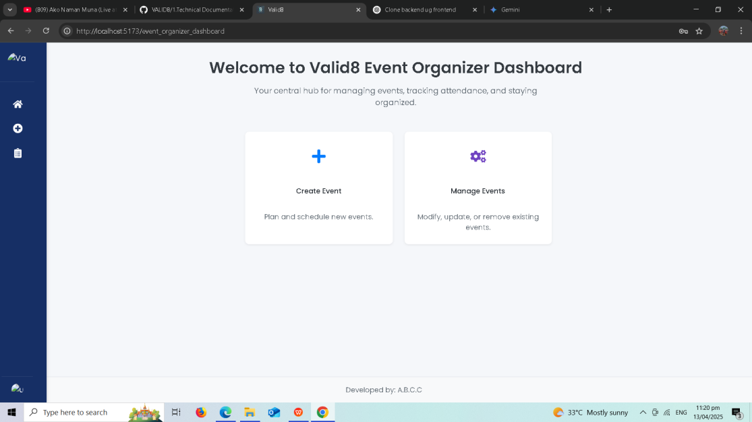

This dashboard serves as your central hub for planning, scheduling, and managing events within the system. It provides quick access to key functionalities related to event organization, such as "Create Event" and "Manage Events." The sidebar on the left provides further navigation.

1. **Creating a New Event**

Clicking the **"Create Event"** panel on the dashboard (or potentially a similar option in the sidebar) will take you to the **Create New Event** form, as shown below:

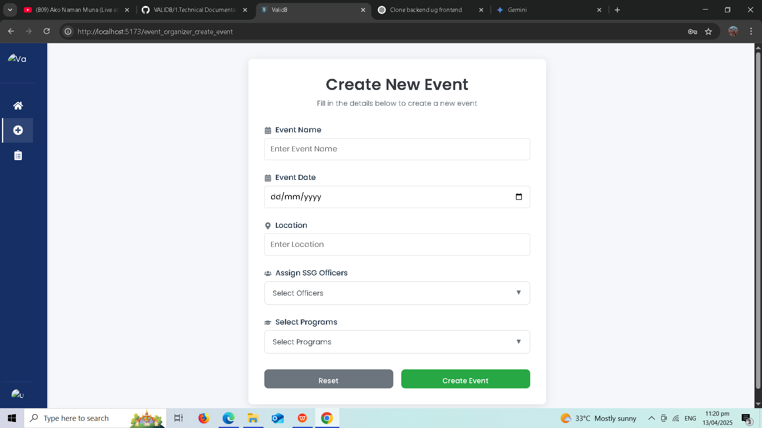

Fill in the details to create a new event, including the Event Name, Event Date, Location, assigned SSG Officers, and selected Programs. Click **"Create Event"** to save or **"Reset"** to clear the form.

1. **Managing Your Events**

Clicking the **"Manage Events"** panel on the dashboard (or the "Events" icon in the sidebar) will take you to the **Event Management** page, as shown below:

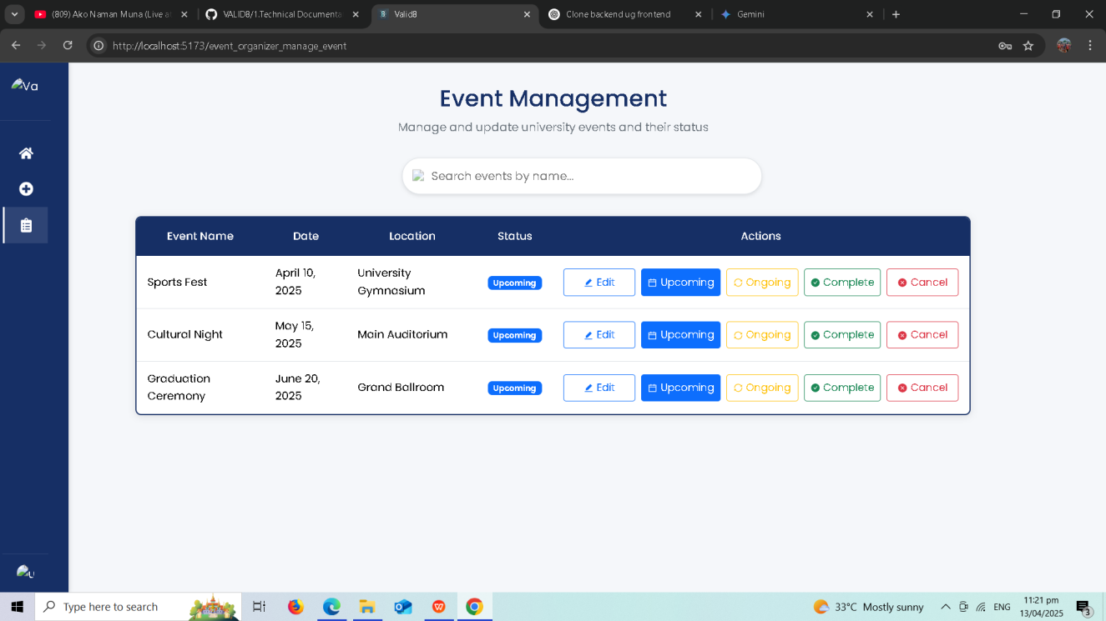

This page lists the events you manage, allowing you to view details, edit information, and update the status using the "**Edit**" button and the status buttons ("Upcoming," "Ongoing," "Complete," "Cancel") in the "Actions" column.

**4.1. Editing Event Details**

Clicking the **"Edit"** button opens the **Edit Event Details** modal:

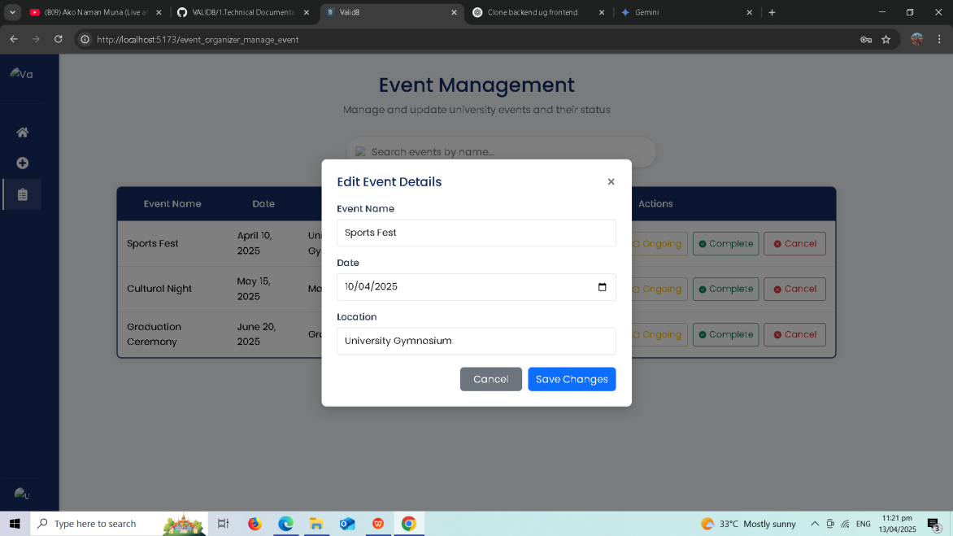

Modify the Event Name, Date, Location, and other editable fields. Click **"Save Changes"** to update or **"Cancel"** to discard changes.

#### 4.2. Updating Event Status Clicking a status button will open a **Confirm Status Change** modal:

Confirm your choice to update the event status by clicking **"Confirm"** or **"Cancel"**.

1. **Managing Your Profile**

Clicking on the **"Profile"** option in the sidebar will navigate you to your **User Profile** page, as shown below:

View your Name, Role (Event organizer), and Email. You can also **Edit Profile** and **Logout**. Clicking **"Edit Profile"** will likely open a view to modify your information (potentially including profile picture):

Make changes and click "**Save Changes**" or "**Cancel**".

Click the **"Logout"** button on the User Profile page to securely sign out of the system. Confirm your action if prompted.

**Conclusion for Event Organizers**

This user guide provides an overview of the key features available to you as an event organizer within the Jose Rizal Memorial State University Event Attendance Management System. You can create and manage events, update their status, and manage your profile. For further assistance, contact the system administrators or IT support.

